14.Light

Very short answer type questions::
- what do we call the image that can be obtained on a screen?
- what type of images formed by a plane?
- what type of lens is also called diverging lens?
- what type of images formed by a concave lens?
- who proved that white light consists of seven colour?

Answers
- Real and inverted image.
- Virtual and erect.
- Concave lens.
- virtual erect and diminished image is formed by the concave lens.
- Sir Isaac Newton
II. short answer type questions
- what is lateral inversion?
- what is Dispersion of light?
- What is refraction of light?
- Define irregular reflection?
Answers
Ans1. your left appear on right side and your right appears on the left side in the mirror that this left right reversal is called lateral inversion.
Ans 2.The phenomenon of splitting of white light into its constituent colours is called Dispersion of light.
Ans 3. When light passes through a spherical surface of the lens it changes its path. This deviation in the path of the light or bending of light rays is called as refraction of light.
Ans. 4. When light is reflected from a rough or irregular surface the reflected ray is scattered in all direction such kind of reflection is called diffused or irrregular reflection.

III. Long answer type question
- list the characteristic of the image formed by the plane mirror.
- Explain the uses of concave and convex mirror.
- why is a rainbow formed. explain the concept briefly
- what is the Newton disc? what does it prove?
Answers
Ans 1. The characteristics of the image formed by plane mirror are as below:
1.The size of the images same as you.
2. your left appear on right side and you right a pair on left side in the mirror this is called lateral Inversion.
3.Image formed is virtual and erect.
4.The size of image neither increases not decreases as you move back or forth from the mirror.
- your image is at equidistant from the mirror.
Ans2. uses of concave mirror are as below:
1.used as shaving mirror as magnify the image placed near it.
2.used by dentist and doctors to concentrate on body parts.
3. concave mirror can concentrate the sun rays falling on them at a point due to this reason they are also used in solar power projects.

Uses of convex mirror
- because convex mirror produces small, virtual and upright image give a wide range of view so they are used as rear view mirror in vehicles ,super markets as security mirrors and in buses so that the driver get the view of the whole bus.

Ans 3. Rainbow occurs due to reflection and refraction occurring from water droplets present in air.
Rainbow is formed when light from the sun passes through a tiny droplets of water present in the atmosphere. white light actually consists of seven colour when the white light passes through water droplet it splits into its constituent colour because every colour has its own frequency and speed of travelling due to which it split into its seven colour.

Ans 4. Newton's disc is a disc with segments in painted in rainbow colours, i.e. violet, indigo, blue, green, yellow, orange and red, in that order. When the disc is rotated, the colors fade to white; Isaac Newton used this disc to demonstrate that white light is a combination of the seven different colours found in a rainbow.
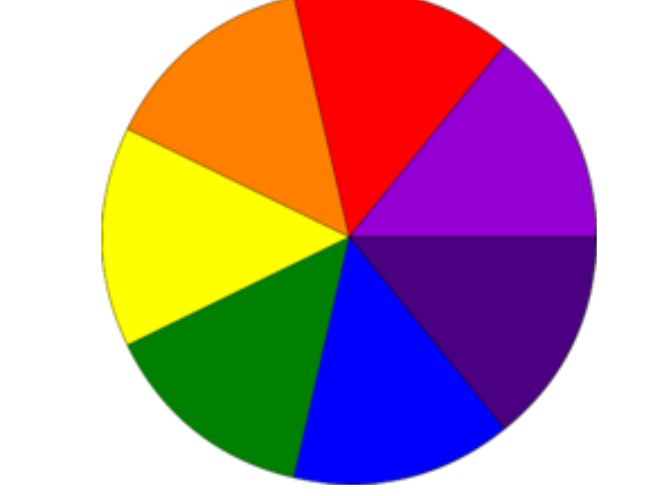

Distinguish between
- real and virtual image(page no. 170)
- Concave and convex lens (page no. 176)
- Concave and convex mirror (page no. 173)
- Concave and plane mirror (page no. 173)
Hots
- why is the word ambulance written reverse on vehicle?
Ans. the word AMBULANCE is written laterally inverted in front of the ambulance because when seen in the rear view mirror by another vehicle, the image of the word would get inverted, letting the driver to read the word properly so that he can provide way to the ambulance.
- if a toy car run towards a plane mirror with a speed of 2m/s then at what speed will the image of the car run towards it?
Ans.If a toy car runs towards a plane mirror with a speed of 2 m/s then the image of the car will run towards the mirror at the same speed, i.e. 2 m/s.

