Class X Python
- Tick the correct answer:
  - Both operands are true
  - 012
  - 2
  - Iteration
  - Infinite
  - 1991
  - IDLE
  - IntPaid
- Fill in the blanks
  - Beginning to end
  - Conditional
  - If statement
  - 4
  - Operator
- Write true or false
  - T
  - T
  - F
  - T
  - T
  - T
  - F
  - T
- Answer in short
  - Generally a program executes its statement from beginning to end. But sometimes, it is not required that programs execute all their statement in strict order from beginning to end. Basically conditional are structures within the code which can execute different lines of code based on certain ‘conditions’ being met.
  - The difference between IF and IF..else statements are:
IF | IF ELSE
The if statement is a decision making structure that consist of an expression  Followed by on or more statements. | The if else statement is a decision making structure in which the if statement can be followed by an optional else statement that execute when the expression is false.
In if, the statement inside the body of if executes only if the test expression evaluates to true . if the expression is false, the next statement after the if block executes. | In if else, the if block executes if the expression is true and if the expression is false , the control is passed to the else block.

  - Four elements of while loops are:
    - Expression initialization: assigning initial value for the variable.
    - Test condition: python uses Boolean variables to evaluates conditions. Test condition refer to the condition of an expression whose truth value decides whether the block of code under loop will be executed or not.
    - Body of the loop: A statement or group of statements that we define the loop is called the body of the loop.
    - Update expression: the update expression changes the value of control variable.
  - Data types are the classification or categorization of data item. It represent the kind of value that tells what operation can be performed on a particulars data. Since python is object oriented programming language so data type is a class and variable are called objects. The different data type are :
    - Numeric: integer, complex, float
    - Boolean
    - Set
    - Sequential type: string, list, tuple
  - Multiline string can be written by adding a backslash(\) at the end of the line before pressing enter or by using triple quotation marks (single or double). This will tell the computer to continue to the next line till the quotation mark.
For example
a = “Hello\
there \
I love python”
Print(a)
Output: Hello there I love python
  - Data types are the classification or categorization of data item. They are important to because they represent the kind of value that tells what operation can be performed on a particulars data. Since python is object oriented programming language so data type is a class and variable are called objects.
  - The standard development environment of python is called IDLE(integrated Development Environment ) , and is easy and suitable for beginners to learn programming in python. It lets user to write, debug and execute code from the same interface. The python text editor has features such as auto-complete, syntax highlighting, smart indent and dynamic typing.
- Answer in detail:
  - Conditional statement are the structure within the code which can execute different line of code based on certain condition being met. With conditional statement, we can have code that sometimes runs and at the other times not run, depending on the condition of the program at that time.
For example IF……else statement
Marks=65
If(marks>60):
Print(“first division”)
Else
Print(“not first division”)
  - Write short notes on:
    - Counting loop: For loop refers to the loop that repeat a certain number of times. It is also known as counter loop.
Format:
For value in sequence:
Body of the loop
Example: n=[1,2,3,4,5] for i in range (n) print(i) output: 1,2,3,4,5
    - . Conditional loop: A while Loop is a conditional loop that is used to iterate (repeat) ever a block of code until a given condition return false. On the contrary when we exactly know how many times we need to run the loop, we use for loop.
Format:
While<condition>
Statement
Update the expression
For example:
n=4
while n<10:
print(n)
n=n+1
print(“loop end”)
Output: 4,5,6,7,8,9
    - Variables are the named memory location created in the main memory of the computer, used to store data. During the program execution. These locations are created and identified by the name given by the user. With the help of these names, values are stored, used, processed and manipulated to produce the result. The different naming rules are;
      - Can be of any size
      - Can have characters A-Z, a-z, 0-9 and underscore(_)
      - Should begin with a letter or underscore
      - Should not be a keyword.
      - Are case sensitive e.g. total and TOTAL are different.
    - Features of python are:
      - Python is easy to learn and use.
      - Python language is more expressive.
      - Python is interpreted language.
      - Python is portable and can run on any platform.
      - Graphics user interface can be developed.
FUN Activity
Python program
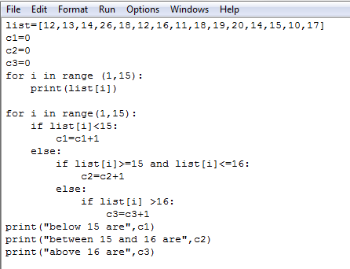
In the Lab
1.
. -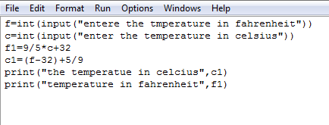
2.
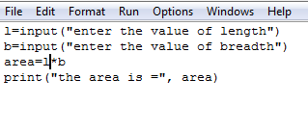
3.
